|  |  |
| --- | --- |
| cetlogo ***CHEMICAL ENGINEERING TRANSACTIONS***  ***VOL. xxx, 2025*** | A publication of  aidiclogo_grande |
| The Italian Association  of Chemical Engineering  Online at www.cetjournal.it |
| Guest Editors: Bruno Fabiano, Valerio Cozzani  Copyright © 2025, AIDIC Servizi S.r.l. **ISBN** 979-12-81206-xx-y; **ISSN** 2283-9216 | |

HEAT RADIATION EMANATING FROM HYDROGEN AND METHANE JET FIRES

Christopher Bernardy \**a*, Abdel Karim Habib *a*, Martin Kluge *a*, Alessandro Orchini b

aBundesanstalt fuer Materialforschung un d-pruefung (BAM)

bChair of Nonlinear Thermo-Fluid Mechanics, Technical University of Berlin

\*christopher.bernardy@bam.de

Modelling the heat radiation emanating from jet flames for initial hazard assessment purposes is generally done using simple, steady-state, approaches that give a quick estimation useful for impact analysis. Although nowadays CFD can be used to simulate this phenomenon in detail, it is still very demanding in computational power and time, and generally not all required boundary conditions to achieve a reliable result are known. Therefore, even today simpler empirical approaches are still widely used for consequence analysis. Hydrogen is becoming increasingly important as renewable energy carrier resulting in an increasing demand of “hydrogen-approved” models. Since the aforenamed models were mainly developed based on data from hydrocarbon jet flame experiments, it has to be verified if they also apply to hydrogen jet flames. To this purpose, real-scale tests are carried out at the BAM Test Site Technical Safety (BAM-TTS) with the aim to assess the flame geometry and the emitted thermal radiation of hydrogen and methane jet flames. In particular, the focus is laid on the measurement and modelling of the thermal radiation. Existing heat radiation data from the literature are mostly based on unsteady outflow conditions. The experimental setup used here allows for the generation of a steady-state outflow and thus a direct comparability with existing (steady-state) models. From these data, an assessment of the applicability of jet flame models to hydrogen jet flames is carried out accounting for their accuracy in predicting heat radiation and possible needs of further development.

Introduction

In the course of the transition from fossil fuels to renewable energy sources, hydrogen will play a decisive role in the future. The versatile application possibilities as an energy source in mobility, the chemical industry or as an energy carrier will lead to a ramp-up of the hydrogen industry. To make this increase in production, transportation, and storage safe, a variety of safety scenarios must be assessed. Usually, hydrogen is stored under high pressure due to its low volumetric energy density.A possible hazard resulting from this is the momentum*-*drivenrelease of hydrogen from a leakage. Due to its low ignition energy, the leaked hydrogen may combust generation a diffusion jet flame. In order to assess the safety consequences and hazards, the resulting jet flame must be characterized with regard to the flame geometry and the heat radiation emitted in the environment. Safety regulations and standards can then be derived from the knowledge gained.

Most of the jet flame models available are based on experimental data by *(*[*Shevyakov & Komov, 1977*](#_ENREF_19)*)*, *(*[*Becker & Liang, 1978*](#_ENREF_1)*)* and *(*[*Kalghatgi, 1984*](#_ENREF_12)*)*, who did fundamental research on the flame geometry of diffusion jet flames. They established dependencies on the outlet diameter, mass flow, Froude Number, Reynolds number and the resulting visible flame length. In addition to the characterization of the flame geometry, the impact of the thermal radiation emitted into the environment was considered in Chamberlain's investigations for vertical outlet conditions *(*[*Chamberlain, 1987*](#_ENREF_3)*)*, mainly for low-momentum hydrocarbon jet flames. For a horizontal release of hydrocarbon jet flames Johnson *(*[*Johnson et al., 1994*](#_ENREF_10)*)* carried out experiments taking into account the influence of buoyancy. Miller *(*[*Miller, 2017*](#_ENREF_13)*)* extended these models to outlet angles of 45°.

The models mentioned are mainly based on a large number of experimental investigations of hydrocarbon flames such as methane and natural gas. For hydrogen, Molkov *(*[*Molkov et al., 2009*](#_ENREF_15)*;* [*Molkov & Saffers, 2013*](#_ENREF_16)*)* derived approaches in which the flame lengths can be described by using empirical formulas in dependency of outlet diameter and mass flow.

Real-scale experiments at constant outlet conditions were carried out at the Test Site for Technical Safety at the Bundesanstalt für Materialforschung und -prüfung (BAM-TTS) ([Bernardy et al., 2024](#_ENREF_2)),. The results shown in this study are now compared to jet flame models calculating the flame geometry as well as the thermal radiation. Moreover, several parameters that influence the heat radiation are discussed.

Experiments

The experiments presented were performed under stationary outlet conditions ([Bernardy et al., 2024](#_ENREF_2)) to enable a comparison with steady-state jet flame models. Two infrared cameras were used (SC4000 and E96 by FLIR Systems) to characterize the flame geometry. They were placed at two different positions (side view and front view) to gather quasi-3D information of the flame. The cameras have a wavelength range of λ=1.5 µm - 5 µm (SC4000) and λ=7.5 µm - 14 µm (E96). The released mass flow was monitored using a Coriolis mass flow meter (Rheonik Coriolis RHE28). Three heat radiation sensors (Medtherm Series 64) were located at a distance of 8 m, 10 m and 12 m from the outlet position, respectively. A fourth sensor was pointing away from the source and used to measure the background radiation of the surroundings.

In total 128 tests were carried out for hydrogen and methane with a mass flow range of $\dot{m}$ = (0.005-0.175) kg/s. Every experiment lasted for 120 s with stationary outlet conditions. The outlet diameter of the pipe was *d*= 30 mm.

Results and Discussion

Although the released mass flow was constant during the release duration, only quasi stationary conditions could be achieved. Since the experiments took place in an open field, unsteady atmospheric conditions lead to a slightly but constantly varying flame shape. To determine a quasi-stationary flame shape, a method to calculate an averaged flame shape over the release duration was developed, in which every pixel value of the IR Recording is time averaged over the whole duration of the experiment.

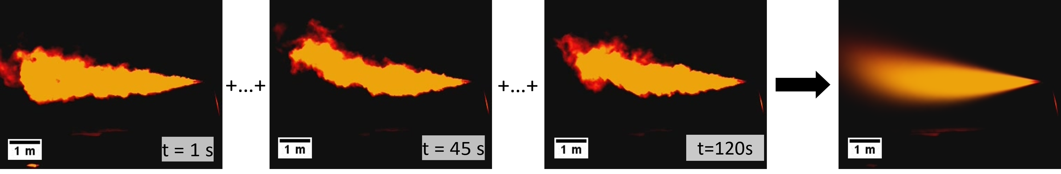

Figure 1: Schematic illustration of averaging flame images over test duration

Figure 1 shows a schematic illustration of averaging the frames of the IR recording to generate a quasi-stationary time averaged picture for each test. The averaged flame shape is then used to define a characteristic flame length and diameter for each experiment. From the individual snapshots, on the other hand, the maximum flame dimensions can be determined. Over all trials, the ratio of mean flame length over maximum flame length is 80 percent.

Figure 2 shows the comparison of the experimental mean flame lengths of hydrogen and methane against results obtained from the model by Molkov *(*[*Molkov & Saffers, 2013*](#_ENREF_16)*)* for hydrogen and Johnson ([Johnson et al., 1994](#_ENREF_10)) for methane. In general, the experimental data for hydrogen flames show a longer flame length than for methane flames. The same holds true when comparing the model calculations from Molkov against Johnson at the same mass flow. The average relative deviation of the flame length of hydrogen against methane for the experimental data is about 15%, whereby the relative deviation decreases with increasing mass flow. The model data of Molkov show a constant overprediction of the experimental values. The overprediction of the flame length by the model of Molkov ranges from 5% for low mass flows up to 20% for higher mass flows. For methane, the comparison with the model of Johnson shows that for low mass flows the model is conservative. When the mass flow exceeds 0.05 kg/s the experimental flame lengths are higher than those predicted by Johnson’s model.

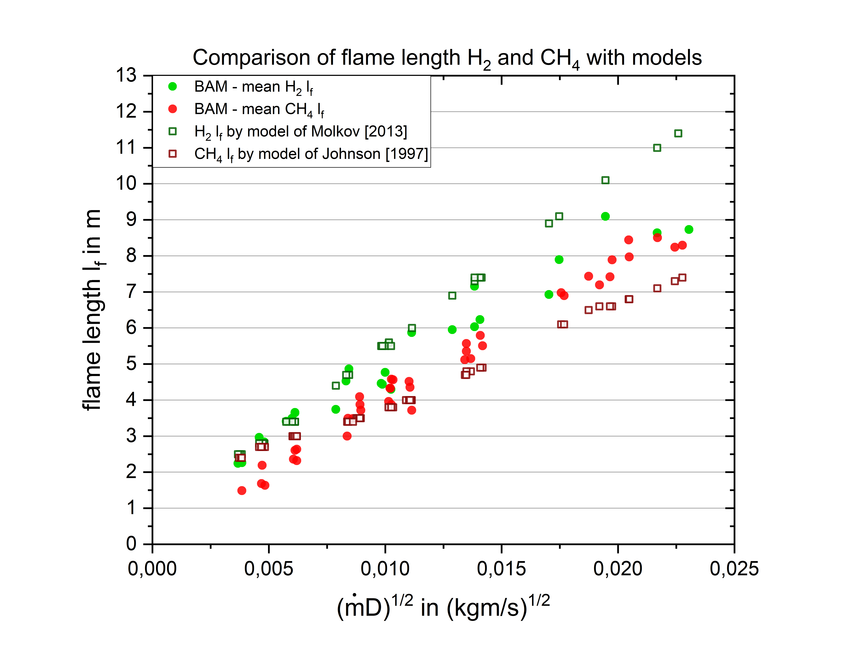

Figure 2: Comparison of H2 and CH4 with models for H2 from Molkov et al. ([Molkov & Saffers, 2013](#_ENREF_16)) and for CH4 Johnson ([Johnson et al., 1994](#_ENREF_10))

Whilst the experimental results shown here are based on an analysis of the IR emissions of the flames, those in the literature are based on unfiltered light emissions as well as for non-stationary outflow conditions, leading to differences in the flame length determination. Thus, the criterion used to define the flame limit, such as luminescent area (used in the models of Molkov and Johnson), or flame temperature in the IR Recording (used for the experiments presented here), is a decisive factor that influences the flame length determination. Moreover, factors such as the wind influence in the free field compared to laboratory conditions without wind and the type of outlet conditions (in/-stationary) are also influencing the flame length determined. The longer flame lengths observed for hydrogen compared to methane are due to the much higher release momentum of the hydrogen jet compared to methane jet (exit velocity ratios hydrogen/methane for the same mass flow of around 8-10).

Figure 3 shows absolute measured heat radiation at the position of each Bolometer over the mass flow. It can be seen that there is a decrease in the radiation from Bolometer 5 – 7, due to their increasing distance from the flame. The aim of the presented work was not to determine heat radiation values in defined distances from the sources, but to quantify the surface emissive power (SEP) of the flame. Therefore, the measured data from the radiation sensors have to be correlated to the flame shape to calculate an SEP for each trial.

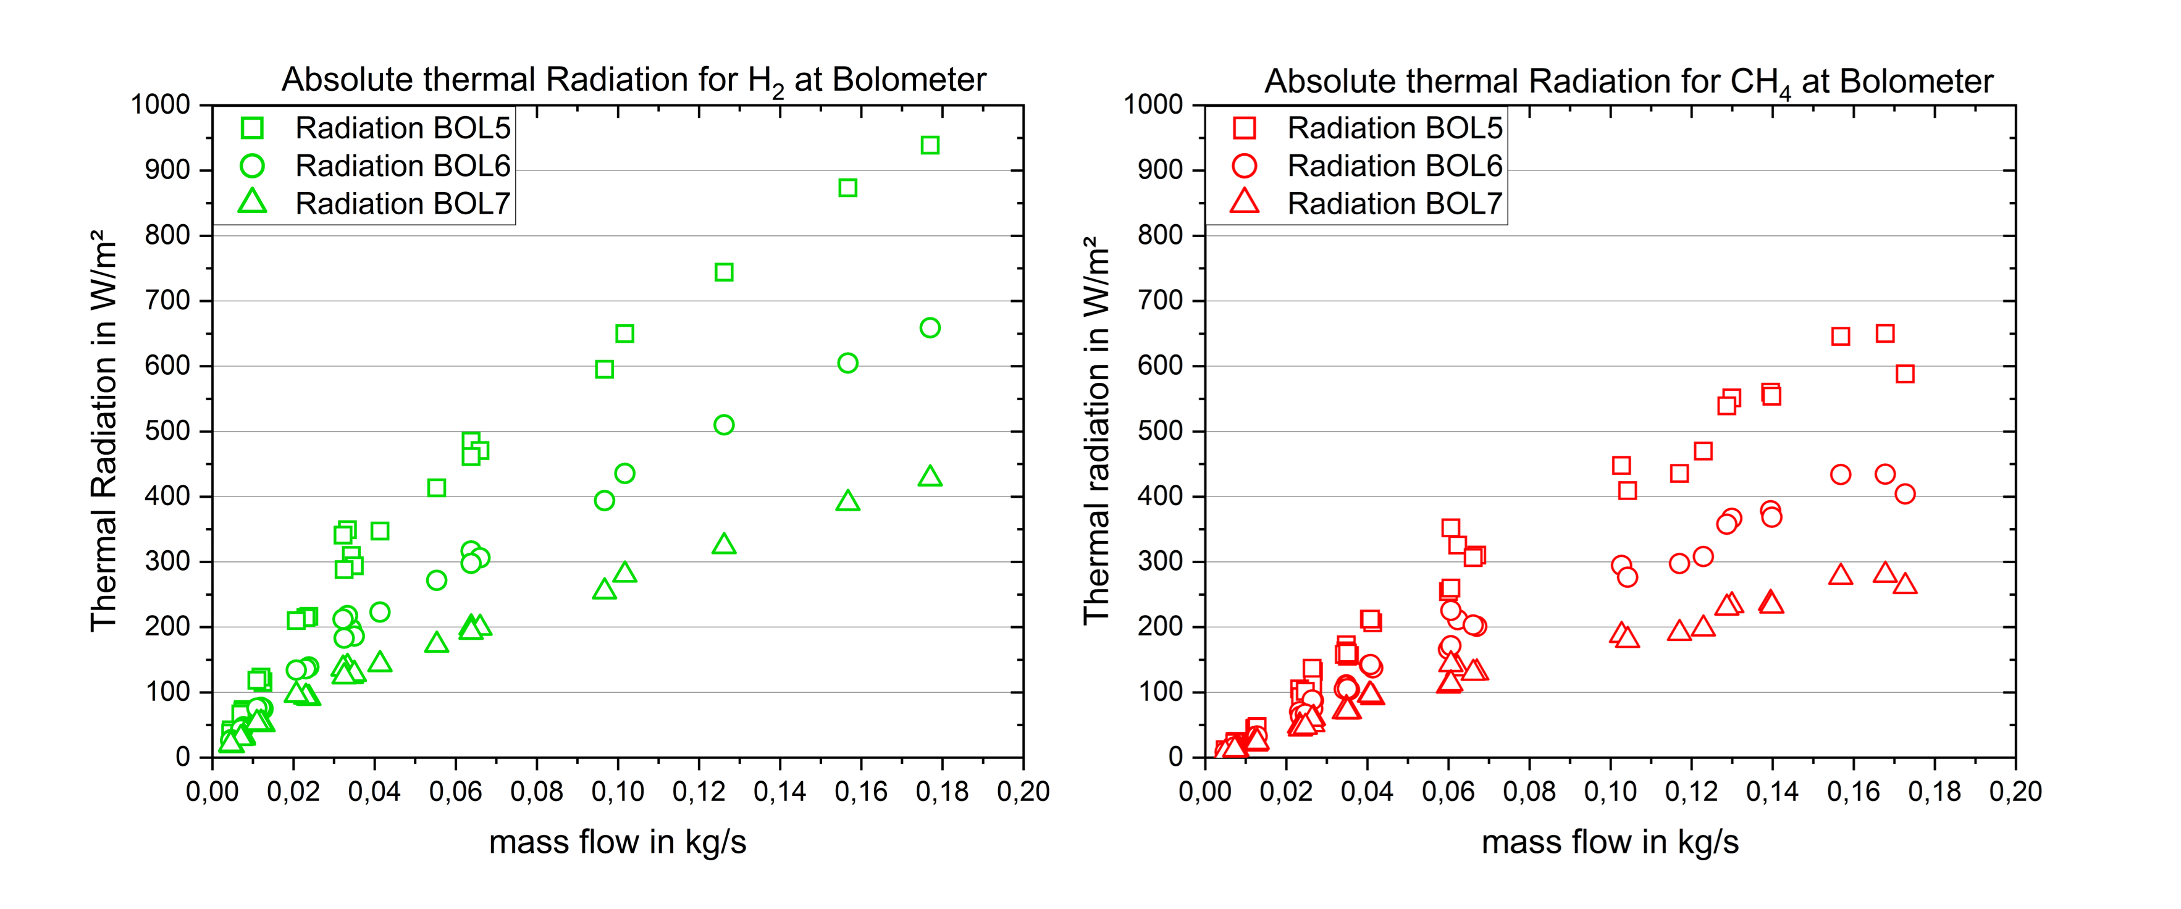

Figure 3: Absolute thermal radiation at Bolometer 5, 6 and 7 in dependency of distance 8,23 m; 10,32 m and 12,31 m for hydrogen (3a) and methane (3b)

From the experimental data, the SEP can be calculated using the formula by ([van den Bosch & Weterings, 2005](#_ENREF_21))

|  |  |
| --- | --- |
| $$SEP=\frac{Q_{rad_Sensor}}{τ_{1_2} φ_{1_2}}$$ | (1) |

where $Q_{rad_Sensor}$ is the measured radiation at the bolometers in W/m², $φ_{1_2}$ (unitless) is the view factor of each flame shape and, $τ_{1_2}$ (unitless) the transmittance of the air calculated according to ([Wayne, 1991](#_ENREF_23)). The index "1\_2" refers to the path between emitter "1" and receiver "2".

The view factor $φ_{1_2}$ describes the correlation of the flame shape and the heat radiation. Existing analytical view factor approaches can be looked up in literature ([VDI, 2010](#_ENREF_22)). A frequently used approach for flames is the cylinder model. Figure 4a shows that an approximation is possible for simple flame structures. For more complex flame shapes, an analytical approximation is not given. Therefore, in this work, a numerical method was developed to determine the view factor. The flames are divided into slices (with one pixel width) corresponding to a “disc” of the flame body. The view factor is then calculated for each slice and integrated across the flame front. The advantage of this method is that the real flame shape can be considered with higher accuracy than by using simple analytical correlations for standard shapes.

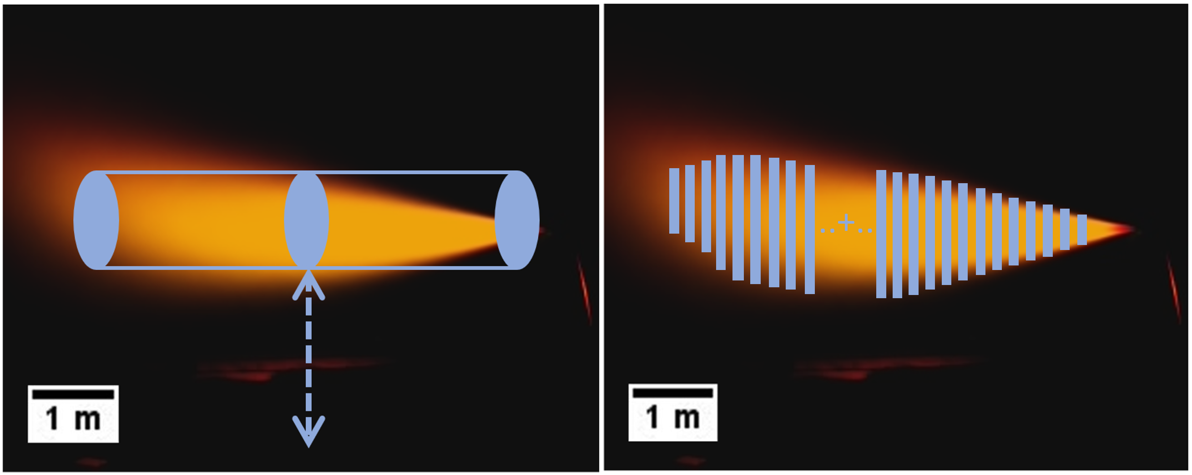

Figure 4: Approximation of analytical cylinder view factor (right 4a) and calculation of numerical view factor (left 4b)

Figure 5 shows the calculated SEP for the hydrogen and methane flames investigated, over the mass flow (calculated to Eq.(**1**)). For each mass flow the SEP was calculated for each Bolometer used. Ideally all three values for the SEP should be the same but as can be seen there is range of 5-15% between them. The reason for this has to be investigated further to determine whether it is due to measurement uncertainties or other effects like e.g. reflected radiation ([Ekoto et al., 2012](#_ENREF_5)). Hydrogen jet flames show higher SEP values than methane jet flames for the same mass flow. An analytical consideration of the SEP shows that the flame temperature, the lower heating value, as well as species specific radiation properties are the main parameters influencing the SEP. In the following a comparison of two analytical approaches for the SEP are discussed. The Stefan-Boltzmann (SB) law for grey gas radiation yields the relation ([van den Bosch & Weterings, 2005](#_ENREF_21))

|  |  |
| --- | --- |
| $${SEP}_{SB}=ε σ T^{4}$$ | (2) |

with *T* the flame temperature in K, $σ$ the Stefan-Boltzmann constant in W/(m²K4) and the unitless emissivity. Alternatively, the SEP can be calculated using a thermodynamic approach ([van den Bosch & Weterings, 2005](#_ENREF_21))

|  |  |
| --- | --- |
| $${SEP}_{therm.}=\frac{x_{rad} \dot{m}{ΔH}_{c}}{A_{flame}}$$ | (3) |

with mass flow $\dot{m}$ in kg/s, ${ΔH}_{c}$ the lower heating value in J/kg, $A_{flame}$ the flame surface in m² and $X_{rad}$ the radiant heat fraction unitless.

To assess the differences between both approaches in the determination of the SEP, an exemplary comparison for a trial with a mass flow $\dot{m}$ = 4 kg/min is carried out. The calculation with the thermodynamic approach provides a value of 12.99 kW/m² for H2 with an average radiant heat fraction of $x_{rad_H2}$ = 0.1 (range from $x_{rad,H2}$ = 0.03-0.16 ([Choudhuri & Gollahalli, 2003](#_ENREF_4); [Ekoto et al., 2014](#_ENREF_6); [Houf & Schefer, 2007](#_ENREF_9); [Schefer et al., 2009](#_ENREF_17))), a lower heating value of 120 MJ/kg ([Uwe Riedel, 2018](#_ENREF_20)) and a flame surface (from the averaged IR Imaging) of $A_{H2_flame}$ = 62.32 m².

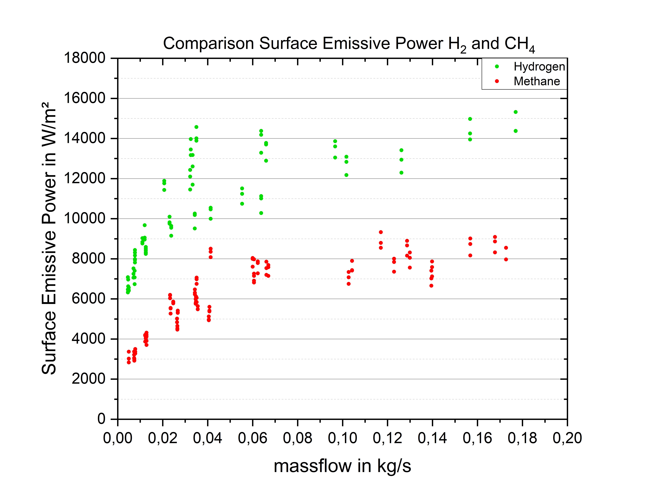

Figure 5: Comparison of Surface Emissive Power for hydrogen and methane over the mass flow.

For methane, a thermal radiation of 11.89 kW/m² can be calculated with an average radiant heat fraction of $x_{rad}$ =0.19 (range of $x_{rad_CH4}$ =0.08-0.3 ([Chamberlain, 1987](#_ENREF_3); [Choudhuri & Gollahalli, 2003](#_ENREF_4); [Johnson et al., 1994](#_ENREF_10))) ,lower heating value of 50.3 MJ/kg ([Uwe Riedel, 2018](#_ENREF_20)) and a flame surface (from the averaged IR Imaging) $A_{CH4_flame}$ = 54.25 m².

The challenge using the SB approach is to define an adequate (flame) temperature for the radiant body. A 10% change in combustion temperature causes a reduction in SEP by 35%. Since flame temperatures are neither homogeneous nor easy to measure, generally the adiabatic flame temperature is used. It has to be considered that the real flame temperature, especially in a turbulent burning regime, will be considerably lower than the adiabatic temperature. Moreover, it is complex to measure ε in a free field for reacting gases, due to ε depends on factors such as the concentration of the combustion species (inhomogeneous for diffusion flames), thickness of the flame (inhomogeneous across the flame centreline), temperature, pressure, and wavelength of the emitting species. Approaches and experimental data for pure gases (H2O and CO2) and mixtures can be found in the studies of ([Hottel et al., 1932](#_ENREF_7); [Hottel & Sarofim, 1967](#_ENREF_8)). Using the adiabatic flame temperature for hydrogen *Tad\_H2* = 2380 K ([Joos, 2006](#_ENREF_11)) and εH2 = 0.1 ([Hottel & Sarofim, 1967](#_ENREF_8); [Mogi et al., 2005](#_ENREF_14)) and for methane *Tad\_CH4* =2222 K and εCH4 = 0.2 ([Chamberlain, 1987](#_ENREF_3); [Hottel & Sarofim, 1967](#_ENREF_8)) results in a SEPH2 of 181.9 kW/m² and a SEPCH4 of 276 kW/m². This clearly shows the enormous differences between the SB and the thermodynamic approach, the latter showing a very good agreement with the experimental data (SEPThermo = 12.99 kW/m² vs SEPExperimental = 10 - 14 kW/m²). Another important parameter, the radiation heat fraction (ratio of the experimental SEP against the theoretical SEP), is found to be in the range of $x_{rad_H2_exp}=$ 0.045-0.09 for H2 and in the range of $x_{rad_CH4_exp}$ = 0.06-0.105 for CH4. A detailed explanation of the calculation can be found in the paper ([Bernardy et al., 2024](#_ENREF_2)). These experimental values are in good concordance with radiant heat fractions published in literature, covering a range of $x_{rad_H2}$ = 0.03-0.16 for Hydrogen and of $x_{rad_CH4}=$ 0.08-0.3 for methane. The experimental radiant heat fraction for methane is more at the lower end of the range given in literature, mostly observed for luminescent natural gas flames. Apart from having investigated pure methane instead of natural gas (with high methane concentrations), this might also be due to the fact that the methane flames studied here showed low to no luminescence. Since the luminescence is mainly caused by radiating soot or carbon particles in the flame which increase the radiant heat fraction, during an incomplete combustion, the flames investigated here seemed to burn in a perfect regime with no observable luminescence and consequently no soot / carbon particles contributing to the flame radiation.([Sherman, 1934](#_ENREF_18))

Conclusion

In summary, an overview of the influencing variables for determining the flame geometry and thermal radiation of jet flames was given. The experimental data were compared with flame length models and showed acceptable agreement with regard to the flame length, especially when considering that the flame lengths were estimated using IR radiation in the presented work, whereas the available models are tuned on flame lengths estimated from luminosity. A method for calculating an averaged flame over the release duration as well as a numerical calculation of the view factor have been presented and used for data processing. The SPE values determined show a good agreement with the thermodynamic approach as well as with radiant heat fraction values found in literature. The SB Approach for the SEP seems unsuitable for jet flames due to its highly sensitive towards the (flame) Temperature and the emissivity.

References

Becker, H. A., & Liang, B. (1978). Visible Length of free turbulent diffusion flames. *Combustion and Flame*, *32*, 115-117. <https://doi.org/https://doi.org/10.1016/0010-2180(78)90087-1>

Bernardy, C., Habib, K., Kluge, M., Schalau, B., Kant, H., Schulze, M., & Orchini, A. (2024). Large-scale investigations of the thermal radiation of hydrogen jet flames. *Journal of Loss Prevention in the Process Industries*.

Chamberlain, G. A. (1987). Developments in design methods for predicting thermal radiation from flares. *65:4*.

Choudhuri, A. R., & Gollahalli, S. R. (2003). Characteristics of hydrogen–hydrocarbon composite fuel turbulent jet flames. *International Journal of Hydrogen Energy*, *28*(4), 445-454. <https://doi.org/https://doi.org/10.1016/S0360-3199(02)00063-0>

Ekoto, I., Houf, W., Ruggles, A., Creitz, L., & Li, J. (2012). *Large Scale Hydrogen Jet Flame Radiant Measurement and Modelling* 9th International Pipeline Conference Calgary, Alberta, Canada. <https://doi.org/10.1115/IPC2012-90535>

Ekoto, I. W., Ruggles, A. J., Creitz, L. W., & Li, J. X. (2014). Updated jet flame radiation modeling with buoyancy corrections. *International Journal of Hydrogen Energy*, *39*(35), 20570-20577. <https://doi.org/https://doi.org/10.1016/j.ijhydene.2014.03.235>

Hottel, H. C., Meyer, F. W., & Stewart, I. (1932). Temperature in Industrial Furnaces: Interpretation and Use to Measure Radiant Heat Flux. *Industrial & Engineering Chemistry*, *28*(6), 708-710. <https://doi.org/https://doi.org/10.1021/ie50318a023>

Hottel, H. C., & Sarofim, A. F. (1967). *Radiative Transfer* McGraw-Hill Book Company.

Houf, W., & Schefer, R. (2007). Predicting radiative heat fluxes and flammability envelopes from unintended releases of hydrogen. *International Journal of Hydrogen Energy*, *32*(1), 136-151. <https://doi.org/https://doi.org/10.1016/j.ijhydene.2006.04.009>

Johnson, A., Brightwell, H., & Carsley, A. (1994). A model for predicting the thermal radiation hazards from large-scale horizontally released natural gas jet fires. *Process Safety and Environmental Protection*, *72*, 157-166.

Joos, F. (2006). *Technische Verbrennung - Verbrennungstechnik, Verbrennungsmodellierung, Emissionen*. Springer Verlag Berlin Heidelberg.

Kalghatgi, G. (1984). Lift-off Heights and Visible Lengths of Vertical Turbulent Jet Diffusion Flames in Still Air. *COMBUSTION SCIENCE AND TECHNOLOGY*, *41*(No. 1-2), 17-29. <https://doi.org/https://www.tandfonline.com/doi/abs/10.1080/00102208408923819>

Miller, D. (2017). New model for predicting thermal radiation from flares and high pressure jet fires for hydrogen and syngas. *Process Safety Progress*, *36*(3), 237-251. <https://doi.org/> <https://doi.org/10.1002/prs.11867>

Mogi, T., Nishida, H., & Horiguchi, S. (2005). Flame Characteristics of high-pressure hydrogen gas jet.

Molkov, V., Makarov, D., & Bragin, M. (2009). Physics and modelling of under-expanded jets and hydrogen dispersion in atmosphere. *Physics of Extreme State of Matter 2009*, 143-145.

Molkov, V., & Saffers, J.-B. (2013). Hydrogen jet flames. *International Journal of Hydrogen Energy*, *38*(19), 8141-8158. <https://doi.org/https://doi.org/10.1016/j.ijhydene.2012.08.106>

Schefer, R. W., Kulatilaka, W. D., Patterson, B. D., & Settersten, T. B. (2009). Visible emission of hydrogen flames. *Combustion and Flame*, *156*(6), 1234-1241. <https://doi.org/https://doi.org/10.1016/j.combustflame.2009.01.011>

Sherman, R. (1934). Radiation from luminous and non-luminous Natural-Gas Flames. *Trans. ASME. Feb 1934, 56(2): 177-185*. <https://doi.org/https://doi.org/10.1115/1.4019691>

Shevyakov, G. G., & Komov, V. F. (1977). Effect of noncombustible admixtures on length of an axisymmetric on-port turbulent diffusion flame. *Combustion, Explosion and Shock Waves*, *13*(5), 563-566. <https://doi.org/https://doi.org/10.1007/BF00742209>

Uwe Riedel, C. S., Jürgen Warnatz, Jürgen Wolfrum. (2018). *Grundlagen der Verbrennung: Wärmefreisetzung und adiabatische Flammentemperaturen*. De Gruyter. <https://doi.org/10.1515/physiko.5.152>

van den Bosch, C. J. H., & Weterings, R. A. P. M. (2005). *Methods for the Calculation of Physical Effects: Due to Releases of Hazardous Materials, Liquids and Gases : Yellow Book*. Ministerie van Volkshuisvesting en Ruimtelijke Ordening (VROM). <https://books.google.de/books?id=v4iEnQAACAAJ>

VDI. (2010). *VDI Heat Atlas*. Springer Berlin Heidelberg. <https://books.google.de/books?id=0t-HrUf1aHEC>

Wayne, F. D. (1991). An economical formula for calculating atmospheric infrared transmissivities. *Shell Research Ltd. , Thornton Research Center, UK 1991*. <https://doi.org/https://doi.org/10.1016/0950-4230(91)80012-J>